**Course: Advance Bio Informatics**

**Module Title: Components of Semantic Web**

**Module No: 68**

**Semantic Web Components**

1. XML
2. Resource Description Framework (RDF)
3. Ontologies
4. Agents

**XML and RDF**

**XML:** HTML (XHTML) is a seriesof predefined tags thatadd presentation to data XML is a series of user-defined tags that add information and structureto data

<author>Imran</author>

Format for presenting information in transmittable form across Internet.

**Issue:** Some mechanism must exist for coordinating the meaning of the user defined tags and for understanding the context of that information.

**Resource Description Framework**

• XML-based language to describe resources

• Resources can include entities, concepts, properties and relations

• Captures the meta data about externals of a document

• Can use a serialized model, RDF triplets, or graphs to describe data

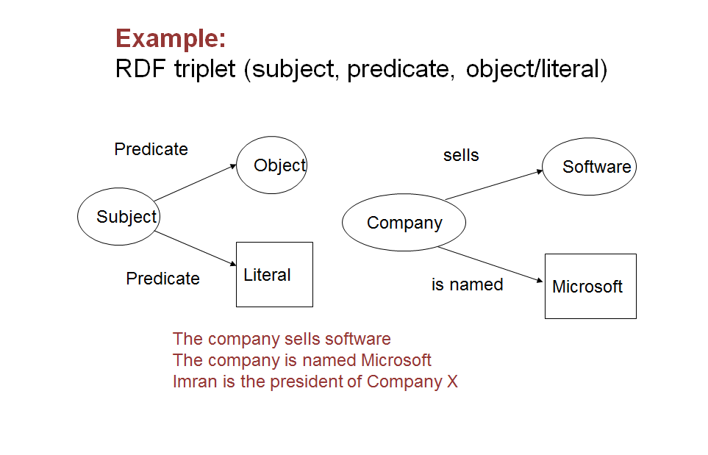

**XML schema:** Defines structure of XML documents Standardizes the communication between systems.

**RDF schema or OWL**: Can be used to define the language used in ontologies and RDFs

**XML and RDF**

Directed graph data model. Set of Binary relations (triples).Subject Predicate Object. NOT like DBMS: Absence of a relation does not mean it is not present.XML and RDF/OWL are inherently different

**XML** = thesaurus document structure

**RDF** = thesaurus document Content

**Recombinant Data Space**

Use graphs rather than statements. These are Aggregate graph. Graphs can be filtered and pivoted, without losing meaning